Adoption
Contract

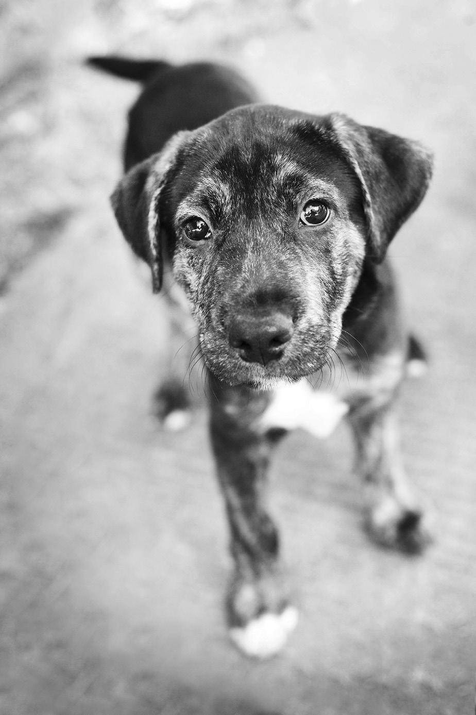
ELECTRONIC:
- Download this application and save it to your hard drive.
- Add your last name to the end of the file name (ie: HS-Adoption-Contract-JONES.doc)
- Complete the form and Save.
- Email the form to rescue@healingspecies.org

PRINTED:
- Print the application.
- Complete.
- Fax to Healing Species at 803-535-6543.
- Or mail to: Healing Species PO Box 1202
Orangeburg, SC 29116

Thank you for your interest in adopting through Healing Species!

Questions? Call 803-535-6543.

By filling out the Healing Species adoption form you assert that you understand and agree to the following stipulations in order to adopt this dog. For the purposes of this agreement, the dog’s name is referenced as ______________________________.

I understand that this agreement is a binding contract.

The true cost of a rescued dog ranges from $600.00 to $1,000.00. The $200.00 adoption fee assists Healing Species with these expenses; however, any amount above the adoption fee is greatly needed and appreciated. All donations are tax-deductible. Thank you for considering adopting a rescued dog whom no one else wanted. You can submit your adoption fee and/or donation via our website www.healingspecies.org/get-involved/donate- today or mail at address given below.

- I agree that this dog will become a part of the family; we require the dog live “inside as part of the family with outside fenced yard” access. Healing Species does not place dogs to “outside only” situations unless there is a unique circumstance explained and approved at adoption.

- I agree to never tether, or “tie on” or “tie out,” or “chain on” this dog. I agree to never crate the dog as a means of daily confinement. This dog will not spend his days within a pen, kennel, or isolated, segregated from family life.

- I agree to provide adequate veterinary care. I agree that this dog will always have a warm, dry, safe place to sleep and adequate comfort, shade, or warmth at all times. I understand that the life of a dog can run into 18 years or more, and that I will need to make provisions to care for this dog for that duration, and upon my death or disability.

- I agree to spay or neuter this dog between 6 and 8 months of age if he or she is not already altered, and to be certain Healing Species is notified, including mailing certification to Healing Species when completed.

- I agree and understand that Healing Species dogs are not to be adopted as a working or hunting dog, but instead as a companion member of a new family. I understand the only exception to working is as a Healing Species therapy dog.

- I agree to allow Healing Species staff to make a follow-up visit. Should Healing Species staff determine that the conditions for this dog’s happiness, well-being, health, or psyche are not the best for the dog; or if the dog shows signs of unhappiness or depression such as: tail tucking, cowering, hiding, skittish behavior, no eye contact, fearfulness, then Healing Species has the right to remove the dog. Healing Species always puts the welfare of the dog above other concerns because animals cannot speak. Healing Species speaks for them. Healing Species is a protection agency for the rescued animals.

Healing Species does its best job to match the perfect dog with the perfect family. We do try to explain any problems or past experiences a former Guardian may have had. Healing Species will never intentionally withhold any information regarding an animal companion. However, once adopted, Healing Species is no longer liable in any way for any occurrence regarding the animal.

- I AGREE THAT, IF THIS DOG DOES NOT WORK OUT WITH YOUR FAMILY, I WILL NOT PLACE HIM OR HER WITH SOMEONE ELSE without FIRST getting approval from Healing Species and having that person fill out Healing Species Adoption Contract.

Healing Species will take the animal back and insists that the Adopter contact Healing Species should the adoption not work out. The Adopter is not free to pass the animal along, give the dog away, or sell the dog, without our written approval, involvement and screening process.
All donations and fees are final.

Personal Information

Your Name (First, Last)

Name of Spouse, Partner or Roommate

Address
City | State | Zip Code
Phone (H) | Phone (W) | Phone (C)
Email
Best Number ❍ Home ❍ Work ❍ Cell | Occupation
Employer

Work Schedule

Birth date: / / / (M/D/Y)

Personal References (Please list three references and their relationship to you. Not all 3 can be relatives.)

Name

Relationship Phone

Name

Relationship Phone

Name

Relationship Phone

Your Veterinarian

Name

Address

City | State | Zip Code
Phone | May we call your vet as a reference? ❍ Yes ❍ No

About Your Pets

Have you ever adopted a companion animal? ❍ Yes ❍ No |  | If yes, type: ❍ Dog ❍ Cat ❍ Other
Where is the pet now?
How many dogs do you have? | Breed/Mix: | Age(s):
How long have you had your current pet?
If none, have you been a pet parent of any dog or animal in the last 10 years? ❍ Yes ❍ No

Where are they currently?

How did you acquire your pet(s)? ❍ breeder ❍ store ❍ adopted / shelter ❍ inherited ❍ rescued ❍ Other:

About Your Pets (Continued)

Do your dogs have any physical problems? ❍ Yes ❍ No | If so, please list.
Do your dogs have any behavioral problems? ❍ Yes ❍ No | If so, please list.
Do your dogs have any dominance problems? ❍ Yes ❍ No | If so, please list.
Do they get along with other dogs? ❍ Yes ❍ No
Have your pets been spayed/neutered? ❍ Yes ❍ No If no, why not?
Are your pets on heartworm preventative? ❍ Yes ❍ No If yes, what type?

About Your Home

Number of Adults | Do all adults in household know you wish to adopt? ❍ Yes ❍ No
Dwelling ❍ Own ❍ Rent | Landlord’s Name (if renting)
Who will be the primary caregiver of this pet? |  | Landlord’s Phone (if renting)
I live in: ❍ Apartment ❍ Duplex ❍ Townhouse ❍ Single House ❍ Mobile Home ❍ Other:

Yard Size | Fenced? ❍ Yes ❍ No | Fence Height
Type of Fence ❍ privacy (all sides) ❍ chain link (all sides) ❍ underground/invisible
Are there any ordinances or restrictions in your county/community about dogs? ❍ Yes ❍ No ❍ Don’t know

Are you moving?  - Yes ❍ No | When? | What will happen to your companion animal(s) if/when you move?
How will your dog spend his/her days? (Select all that apply.)

- Indoors with whole or part house access ❍ Crated ❍ Basement ❍ Garage ❍ Open Porch ❍ Screened Porch
- Sun Room ❍ Chained ❍ Locked in room ❍ Fenced Yard ❍ Loose in unfenced yard ❍ Tied Outside
- Kennel Run ❍ Outdoor Pen w/ dog house ❍ Outdoor Pen w/out dog house How do you plan to discipline the dog?
Healing Species does not condone hitting a dog for any reason. Healing Species endorses the teaching technique of turning your
back on undesirable behavior, and rewarding desirable behavior. For potty training, we encourage doggie door access or providing opportunity to visit grassy outdoors numerous times throughout the day, i.e.: early morning, afternoon, and last thing at night. Dogs that are given opportunity to potty outside will prefer to potty outside.

How will your dog spend his/her nights? (Select all that apply.)

- Indoors with whole or part house access ❍ Crated ❍ Basement ❍ Garage ❍ Open Porch ❍ Screened Porch
- Sun Room ❍ Chained ❍ Locked in room ❍ Fenced Yard ❍ Loose in unfenced yard ❍ Tied Outside
- Kennel Run ❍ Outdoor Pen w/ dog house ❍ Outdoor Pen w/out dog house Healing Species reserves the right to not adopt to non-fenced yard adopters.

About Your Home (Continued)

What will happen to your dog when you have to travel or have an emergency away from your home? (Select all that apply.)

- Pet sitter ❍ Family member or friend will look after ❍ Board at kennel ❍ Will take with me ❍ Leave in yard
- Leave in house

How many hours do you leave your pets alone each day? ❍ 2-4 ❍ 4-6 ❍ 6-8 ❍ 8-10 ❍ 10-12 ❍ 12-14 ❍ 14+

How do you plan to house train your dog?

Do you understand that changing a dog’s environment may cause the dog to have accidents? ❍ Yes ❍ No How will you handle scratching, destruction, and chewing?
Under what circumstances might you consider giving up your dog? (Select all that apply.)

- Moving ❍ Baby ❍ Not Getting Along with Other Pets ❍ Behavioral Problems ❍ Children Lost Interest
- Too Time Consuming ❍ Allergies ❍ Separation/Divorce ❍ Medical Problems ❍ House Breaking
- Other (please describe)

Home Visit

I/we agree to allow you to visit my/our home as part of our application or your follow-up process. ❍ Yes ❍ No

Application Information

All of the information I/we provided in this application is true and correct. I agree that if any of the information changes, I/we will advise you promptly. ❍ Yes ❍ No

Healing Species takes special care to try and ensure that all dogs in our adoption program are healthy and of suitable temperament for adoption. However, because the background of these dogs is uncertain, due to the fact they are rescued, it is impossible to guarantee with 100% certainty their complete medical history or temperament. Regarding adult dogs – It is highly recommended, in the beginning of the new family relationships until the dog is fully acclimated – that new introductions are taken slowly; that introductions to other new dogs are taken with caution; that adult supervision is maintained during possible stressful, noisy, or excitable situations to prevent any mishaps.

Agreement

Signed Name
Date

Healing Species will be in touch regarding your application.
If you have questions, please contact us online at healingspecies.org or by calling 803-535-6543. Thank you!

Adoption Facilitator Only

Comments:

Name of dog: Dog’s adoptive name:

Adult Puppy

Adoption Fee $

Cash Check # PayPal

Adoption facilitator and date:

